- \Operation\Monitoring, carton code\Monitoring, carton code
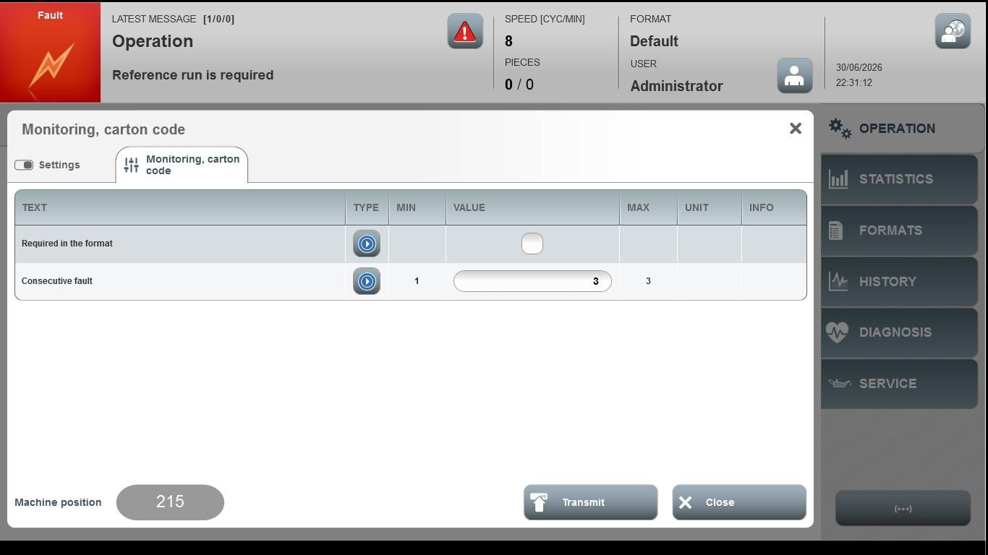
Acceptance criterion | Limits | Pass / Fail: Dev-No. | Date | Initials
Screen matches screenshot | N / A
Consecutive fault | 1 … 3

